2014 Lead Line Dressage Test A

PURPOSE: To introduce riders to the dressage arena and to have FUN!
Requirements: Medium Walk
8 – 10 Meter Circle

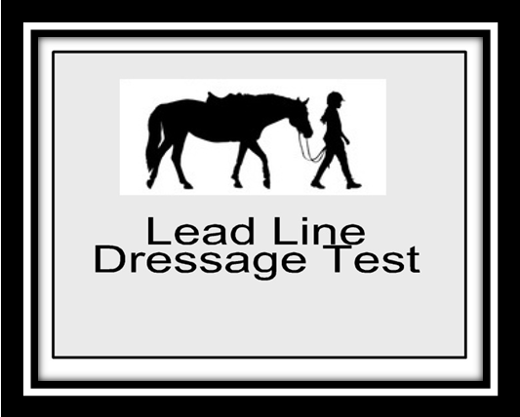
Test Directive Ideas Remarks
A  X  C | Enter down centerline at the walk.  Halt Salute. Proceed at the walk  Turn Right at the walk | Straightness on Center Line  Balance of turn | 10
M | Circle right 8-10 meters | Steadiness of walk | 10
B  E | Turn right at the walk  Turn left at the walk | Balance of turn  Balance of turn | 10
K | Circle left 8-10 meters | Steadiness of walk | 10
A  X | Down Center line at the walk  Halt Salute. | Straightness on center line | 10
Leave arena in walk exit at A

Rider Marks
Position of Rider | 10
Use of Aids, Independence from leader | 10 | 2

Subtotal
Errors | ( )
Total Points
Further Remarks

