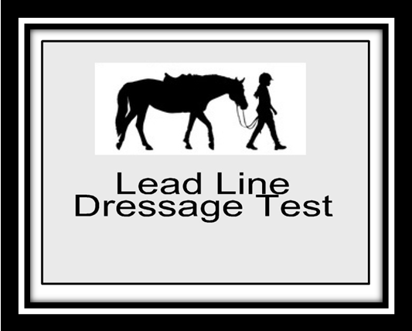2014 Lead Line Dressage Test C

PURPOSE: To introduce riders to the dressage arena and to have FUN!
Requirements: Medium Walk, Working Trot
8 – 10 Meter Circle

Test Directive Ideas Remarks
A  X  C | Enter down center line at the walk  Halt Salute. Proceed at the walk  Turn Left at the walk | Straightness on Center Line  Balance of turn | 10
Btw H and K | Develop Working Trot | Steadiness of trot | 10
K | Walk | Quality-Transition | 10
A | Circle left 8 – 10 meter | Roundness of Circle | 10
FXH | Change Direction across Diagonal at the walk | Steadiness of Walk | 10
C | Circle right 8-10 meter | Roundness of Circle | 10
Btw M and F | Develop Working Trot | Steadiness of Trot | 10
F | Walk | Quality-Transition
A  X | Down Center line at the walk  Halt Salute | Straightness on center line | 10
Leave arena in walk exit at ARider Marks
Position of Rider | 10
Use of Aids, Independence from leader | 10 | 2

Subtotal
Errors | ( )
Total Points
Further Remarks

